10.Create a simple cloud software application for online super market using any Cloud Service Provider to demonstrate SaaS with the template of customer name, address, phone, email, items, quantity etc. with the item classification form

Step 1:Create the form for the booking items in the Groceries

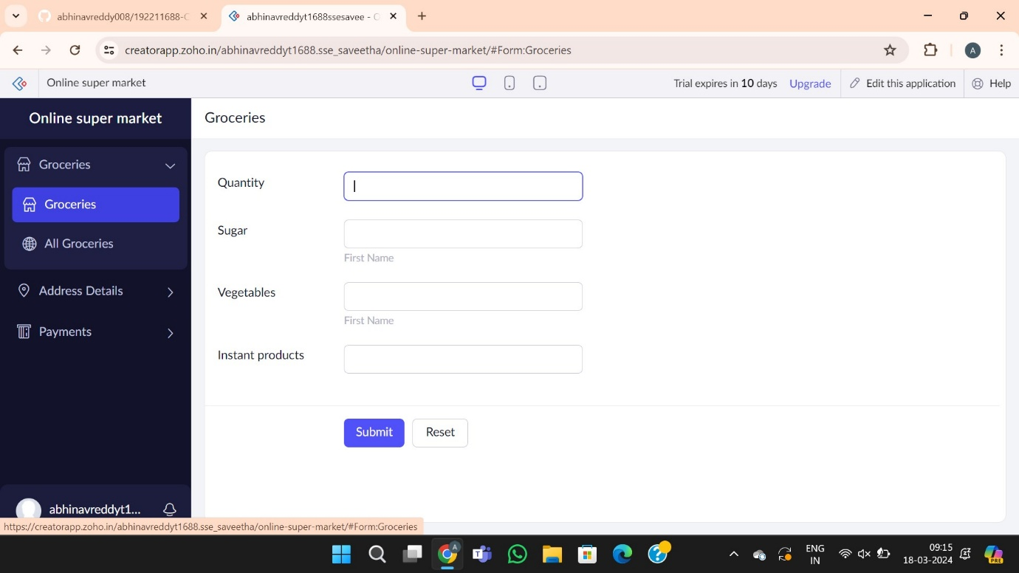

Step 2: Create the form the delivery address

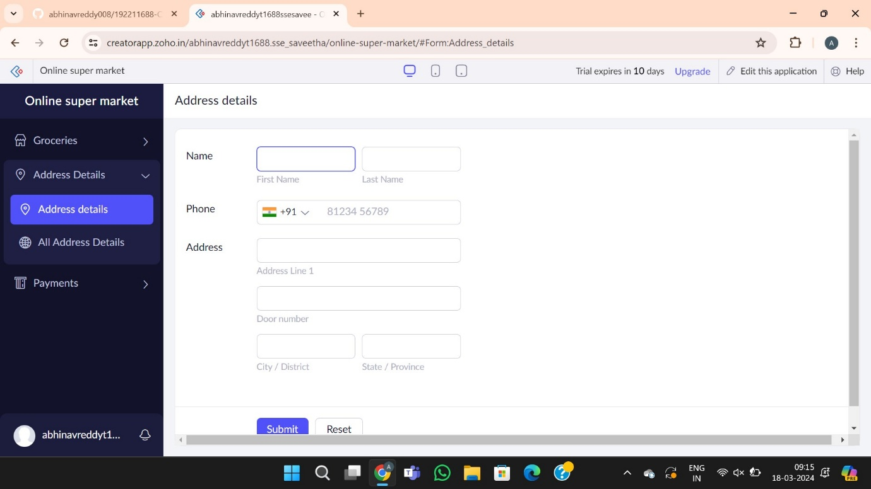

Step 3:Create the form for the payments

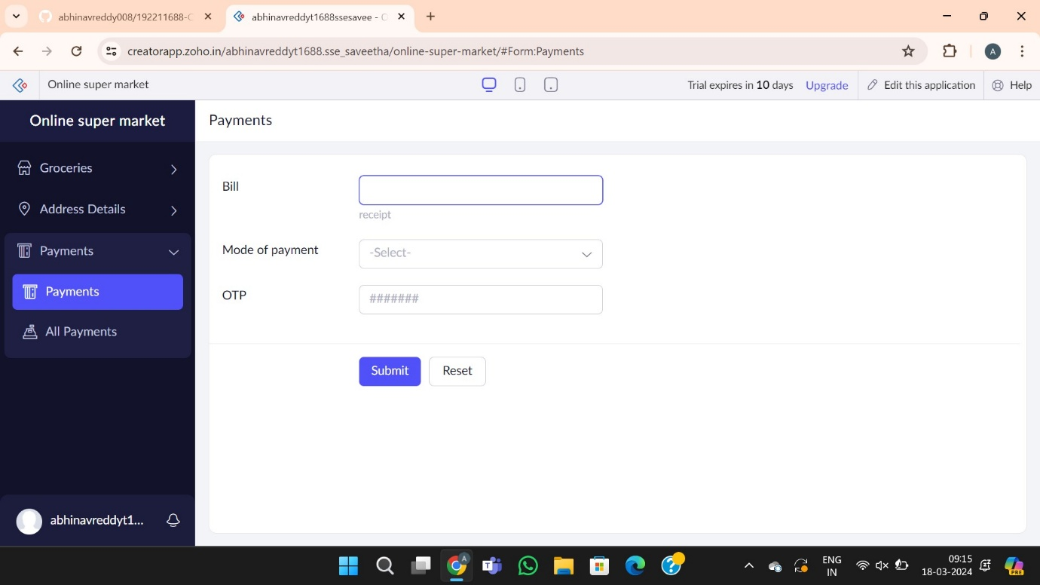

Step 4:Report forms for the Online Shopping system